Spectrometer Logger
Author: Yen-Chun Huang
Date: 02/06/2024

Goal
The spectrometer logger is a python-based logging script to record and monitor the devices status all day.

Python Requirements
OS: Windows
Minimum Version: Python 3.6

Installation

Download from GitHub
https://github.com/Bridge12Technologies/pyB12LOG

After downloading, type the command in terminal window:
pip install -e pyB12LOG

Pip Install
Pip install pyB12LOG

General Usage of pyB12logger
The pyB12logger is used to log data/status from instruments. When first start the logger, some configuration files and log folders will be created automatically. To start or control the logger, type the following command in terminal window. Please be advised that the options of startup and desktop are only available in the administration mode.

pyB12logger [-h] [-desktop {True,False}] [-startup {True,False}] [-debug {True,False}] [{start,stop}]

Arguments/Options | Description
{start, stop} | To start or stop logger. If no arguments or options present, it will be set to ‘start’
-h --help | Show help message
-desktop {True, False} | Create desktop icons
-startup {True, False} | Enable or disable pyB12logger running when startup
-debug {True, False} | Start pyB12logger with console window

Log Data and Debug Log
The device logging files are in C://Users/Public/B12TLOG.The format of file name is ‘log_YYYYMMDDHHMM.csv’. The file size is less than 100 kB by default. The debug_log.txt is saved in this folder. The file size can be configured by a user.
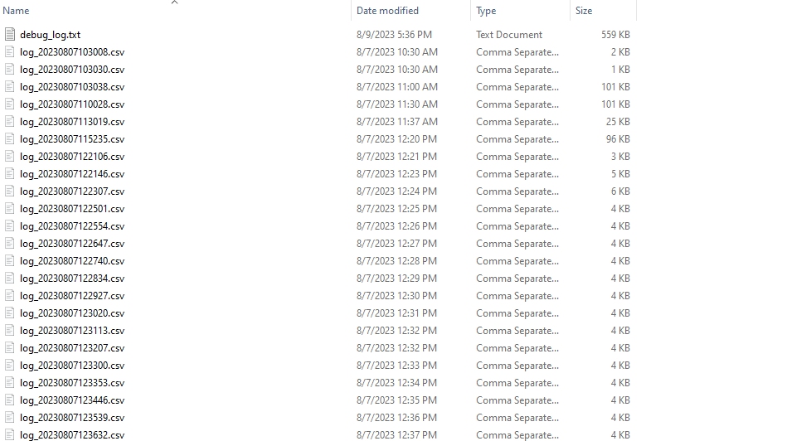

Logger Configuration
The default configuration file is in C://Users/Public/B12TLOG_Config/config.cfg. A user can modify the configuration and add devices configuration in the following example format.
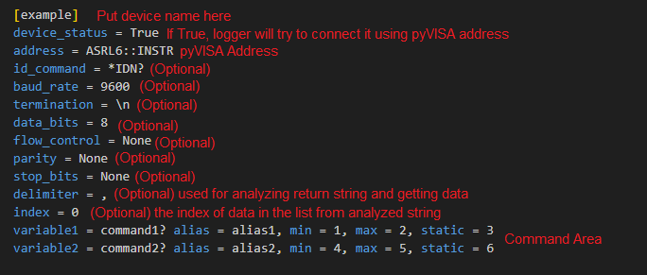

In the command area, the logger will send the commands (e.g. command1 & command2) to devices, analyze return string and assign the analyzed data to the variables (e.g. variable 1 & variable 2). In logger and in monitor, variables are used as headers for saving and reading, respectively.

The alias is the user defined name to identify the data curve in monitor. The rest three elements (min, max, static) are used for warning indicting in the monitor. All these four elements are not required.

pyB12monitor
The pyB12monitor is used to plot historical data in real-time or static way. To start the monitor, type one of the following commands to start.

Commands | Description
pyB12monitor | Start the plotting
pyB12monitor_debug | Start the plotting with console

Usage of pyB12monitor
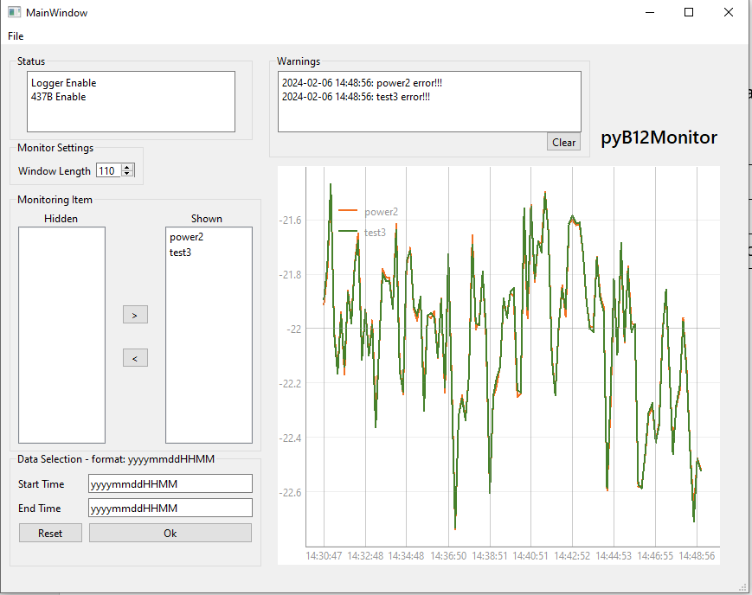
Status: showing the status of devices and logger.
Warnings: showing the warnings of devices based on the given ‘min’, ‘max’ or ‘static’ in configuration file.
Window Length: the number of data points shown in the figure.
Hidden: the available items to shown in the figure.
Shown: the items shown in the figure.
Arrow Buttons: show or hide the selected data.
Start Time & End Time: Both can be optional. Click ‘OK’ to review the static data within the given time range and click ‘Reset’ to review the live figure.
File (menu bar): select file to plot. Click ‘Reset’ to review the live figure.

Please be notified that the settings will be automatically saved and retrieved when pyB12monitor restarts.

